Debra K. Shaffer
October 23, 1956 – March 29, 2020

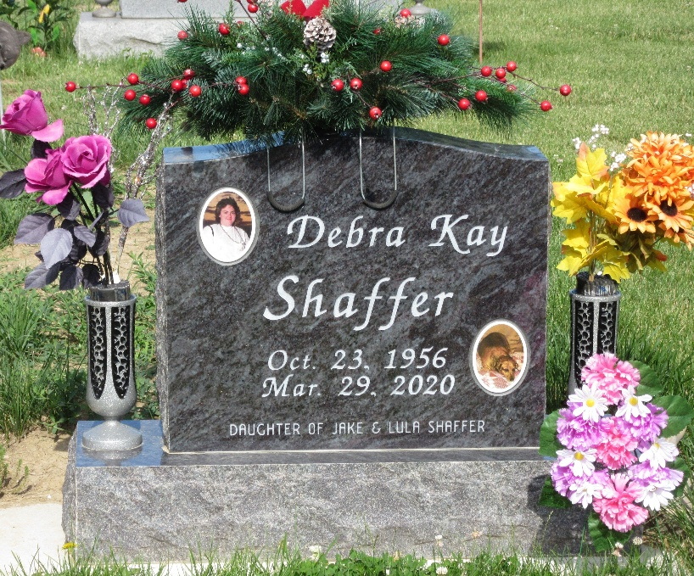
Photo by PLS

Debra K. Shaffer, 63, and a lifelong resident of Decatur, Indiana passed away Sunday morning, March 29, 2020 at Visiting Nurse & Hospice Home in Fort Wayne. She was born on October 23, 1956 in Decatur, Indiana to Jake and Lula (Wolfe) Shaffer.
Debra was a self-employed beautician and caregiver to the Shaffer family. She had previously worked at Decatur Glove Factory. She loved to crochet and was an excellent cook.
She is survived by four sisters, Ilene Dailey of Berne, Indiana, Bonnie Griggs of Owensboro, Kentucky, Barbara Shaffer and Nancy Shaffer both of Decatur, Indiana; and four brothers, Harlan “Bus” (Patsy) Shaffer of Monmouth, Indiana, David Shaffer and Larry Shaffer both of Decatur, Indiana; and Terry (Carla) Shaffer of Convoy, Ohio.
She was preceded in death by three brothers, Don “Bud” Shaffer, Charles “Short” Shaffer, and Jerry “Jug” Shaffer and two sisters, Patsy Blew and Connie Hess.
Due to guidelines established by the State of Indiana in response to the COVID-19 pandemic, private family services will be held. Burial will take place at Decatur Cemetery.
Arrangements by Zwick & Jahn Funeral Home in Decatur, Indiana.

Zwick & Jahn Funeral Home, Adams County, Indiana
March 31, 2020

