Charles J. Shaffer
November 1, 1938 – February 13, 1999

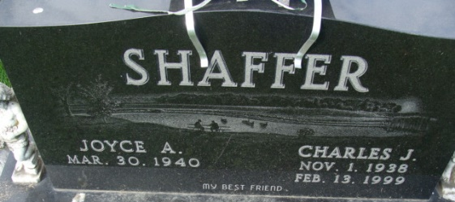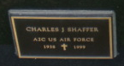
Photo by Alicia Kneuss

Charles J. "Short" Shaffer, 60, of Decatur, a member of Zion Lutheran Church, died Saturday, Feb. 13, 1999, at Lutheran Hospital. The Decatur native retired in 1988 from International Harvester after almost 30 years of service.
Surviving are his wife, Joyce A.; a daughter, Tammy L. Shaffer of Fort Wayne; sons Lyle G., Dennis L. and Cary D., all of Decatur, and Todd A. of Monroe; his mother, Lula Shaffer of Decatur; brothers Donald, Harlen, Jerry, Terry, Larry and David, all of Decatur; sisters Connie Hess, Barbara, Debra and Nancy Shaffer, all of Decatur, Ilene Dailey of Berne, Patsy Belew of Nunnelly, Tenn., and Bonnie Griggs of Owensboro, Ky.; and two grandchildren.
Services are 10 a.m. Tuesday at Zwick & Jahn Funeral Home, Decatur, with calling from 2 to 5 and 7 to 9 p.m. today. Burial with military graveside services will be in Decatur Cemetery, Decatur.
Memorials are to Zion Lutheran Church New Life Center.

News-Sentinel, Allen County, Indiana
Monday, February 15, 1999
**
Indiana, U.S., Death Certificates, 1899-2017
Name Charles J. Shaffer
Gender Male
Race White
Age 60
Marital Status Married
Birth Date 1 Nov 1938
Birth Place Decatur Indiana
Death Date 13 Feb 1999
Death Place Fort Wayne, Allen, Indiana, USA
Death Registration Date 1999
Father Jake Shaffer
Mother Lula Wolfe
Spouse Joyce A Kirchner
Informant Mrs. Joyce A. Shaffer; wife; Decatur, Indiana
Burial February 16, 1999; Decatur Cemetery; Decatur, Indiana

