Cecil E. “Red” Shaffer
August 1, 1913 – January 4, 1981

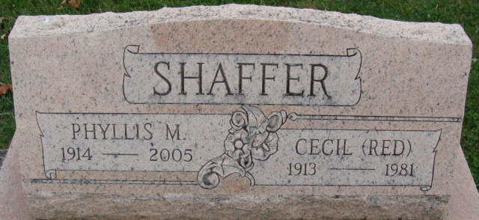
Photo by Alicia Kneuss

Cecil E. Shaffer
in the Indiana, U.S., Death Certificates, 1899-2017
Name Cecil E. Shaffer
Gender Male
Race White
Age 67
Marital Status Married
Birth Date 1 Aug 1913
Birth Place Indiana
Death Date 4 Jan 1981
Death Place Decatur, Adams, Indiana, USA
Death Registration Date 1981
Father Erwin Shaffer
Mother Lula Augenbaugh
Spouse Phyllis Bonifas
Informant Mrs. Cecil Shaffer; Decatur, Indiana
Burial January 7, 1981; Decatur Cemetery; Decatur, Indiana

