Carolyn S. (Miller) Shaffer
February 23, 1939 – December 25, 2023

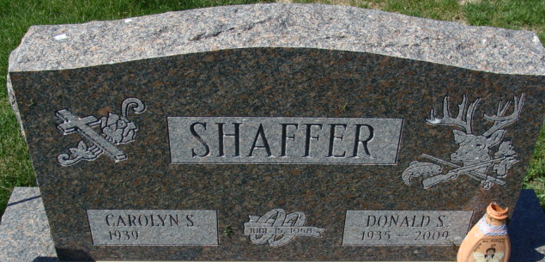
Photo of Alicia Kneuss

Carolyn S. Shaffer, 84, of Decatur, Indiana passed away on Monday, December 25, 2023, at Lutheran Hospital in Fort Wayne, Indiana.
She was born on February 23, 1939, Harlan, Indiana to the late Nevin Miller and the late Florence (Tinkham) Miller. Carolyn was united in marriage to Donald S. "Bud" Shaffer on July 15, 1958, and he preceded her in death on December 1, 2009. She served her family as homemaker. Carolyn loved her grandchildren and great-grandchildren.
Survivors include five sons, Jeffrey A. (Laura) Shaffer, Michael E. (Michele) Shaffer, Steven W. (Marnie) Shaffer, Brian S. (Tracy) Shaffer all of Decatur, Indiana and Ricky L. (Lisa) Shaffer of Ohio City, Ohio; brother, Carl (Linda) Miller of Decatur, Indiana; sister, Patsy (Harlan) Shaffer of Decatur, Indiana; sister-in-law, Jane Miller of Florida; 14 grandchildren; Mindy (Eric) Uhlman, Jackquelyn (Lucas) Faulk, Jennifer (Zachary) Chilcote, Jessica (Amit) Mane, Jillian (Ron) Everett, Ashley (Dave) DiCosimo, Samantha Shaffer, Sarah Shaffer, Corey Shaffer, Ricky (Stacey) Shaffer, Kurtis Shaffer, Jakob (Shana) Shaffer, Grayson Shaffer, and Gracie Shaffer; and 23 great-grandchildren.
In addition to her parents and husband Carolyn was preceded in death one son, Donald Wayne Shaffer, one grandson, Justin Shaffer; and brother, Bob Miller.
A funeral service will be held at 10:00 a.m. Friday, December 29, 2023, at the Zwick & Jahn Funeral Home in Decatur, Indiana with Pastor Harold Klinker officiating. Burial will follow in the Decatur Cemetery.
Family and friends will be received from 3:00 to 7:00 p.m. Thursday, December 28, 2023, at the Zwick & Jahn Funeral Home in Decatur, Indiana and one hour prior to the service on Friday at the funeral home.
Preferred memorials can be given to Riley Children’s Hospital.

Zwick & Jahn Funeral Home, Adams County, Indiana
December 26, 2023

