John W. Shafer
June 20, 1873 – May 11, 1951

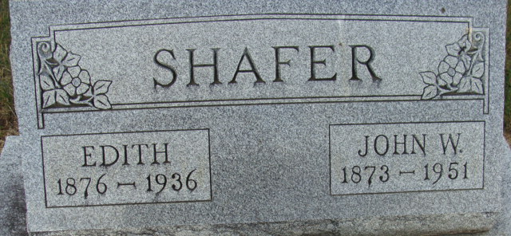
Photo by Alicia Kneuss

John W Shafer
in the Indiana, U.S., Death Certificates, 1899-2017
Name John W Shafer
Gender Male
Race White
Age 77
Marital Status Widowed
Birth Date 20 Jun 1873
Birth Place Bucyrus Ohio
Death Date 11 May 1951
Death Place Rural, Adams, Indiana, USA
Death Registration Date 1951
Father George Shafer
Mother Sarah Wert
Informant Mrs. Lelah Gerber; Decatur, Indiana
Burial May 14, 1951; Decatur Cemetery; Decatur, Indiana

