Edith (Wherry) Shafer
February 8, 1876 – November 20, 1936

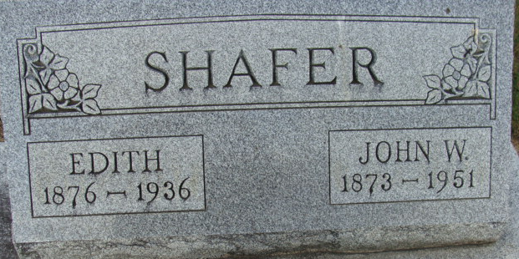
Photo of Alicia Kneuss

Decatur, November 21 - Mrs. John W. Shafer, 60, lifelong resident of Adams County, died at the Adams County Memorial Hospital Friday night following an operation. The deceased was born in Union Township February 8, 1876, the daughter of Joseph and Elizabeth Wherry.
Surviving are the husband and the following children: Mrs. Lela Irene Gerber, Fort Wayne; Joseph R., South Bend; Rev. G. Kenneth, Cincinnati, O., and the following brothers and sisters: Mrs. C. L. V. Sheets, Convoy, O.; Mrs. T. A. Johnson, Youngstown, O.; Mrs. Gertrude Hite, Detroit, Mich.; Mrs. Christ Miller, Root Township; J. A. Wherry, Monroeville and W. A. Wherry, Union Township.
Funeral services will be held at the home in Root Township at 1:30 pm Monday and at 2 o'clock at the First Presbyterian Church in this city.
Burial in Decatur Cemetery.
Journal-Gazette, Allen County, Indiana
November 21, 1936

