Kenneth Wayne Shady
December 30, 1954 – October 4, 2015

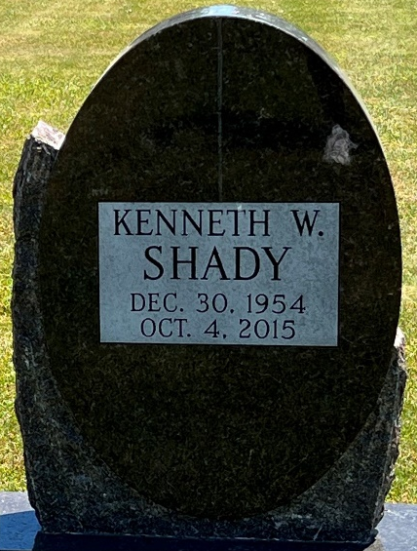
Photo of Deb Curry

Kenneth Wayne Shady, 60 years old of Decatur, Indiana, passed away on Sunday, October 4, 2015 following a brief illness at St. Anthony Memorial Hospital in Michigan City, Indiana.
Kenneth was born on December 30, 1954 in Adams County, Indiana the son of the late Jack Shady and the late Florence (Lehrman) Shady.
Kenneth was a self-employed construction worker.
Surviving is his sister, Carol (Michael) Terhune of Decatur, IN; sister, Joan Roth of Decatur, IN; brother, Dennis (Sue) Shady of Decatur, IN.
Private family burial will be in the Decatur Cemetery.

Haggard & Sefton Funeral Home, Adams County, Indiana
October 5, 2015
**
Indiana, U.S., Death Certificates, 1899-2017
Text Only

Name Kenneth Wayne Shady
Gender Male
Race White
Age 60
Birth Date 30 Dec 1954
Birth Place Adams, Indiana
Death Date 4 Oct 2015
Death Place Michigan City, Laporte, Indiana, USA
Death Registration Date 2015
Father Jack Shady
Mother Florence Lehrman
Certificate Number 047990

