William Shackley
June 14, 1870 – August 26, 1944

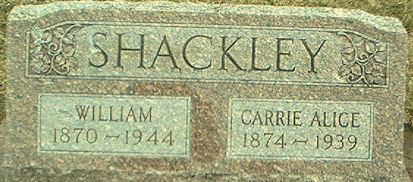
Photo by Alicia Kneuss

WM. SHACKLEY DIES

Funeral services were held at the Black Funeral Home in Decatur this afternoon for William Shackley, 74, a former local resident, who died in Decatur on Saturday morning at the county hospital following a three weeks' illness.
He was a native of Bangor, Maine. His wife, who was Cary Alice Elzey died in 1939 Four sons survive. They are Lloyd and Raymond Shackley, both of Decatur, Glenn of Moline, Ill., and Ear of Van Wert, O.; and two daughters, Mrs. Roy Davis and Miss Ireta Shackley of Fort Wayne.

The Berne Witness; Adams County, Indiana
Monday, August 28, 1944
**
William Shackley from tree Shackley Family Tree
Birth 14 Jun 1870 Boston, Suffolk, Massachusetts, USA
Marriage 14 Aug 1897 Adams, Indiana, USA
Residence 1945 Oakland, Michigan, USA
Death 26 Aug 1944 Decatur, Adams, Indiana, USA
Father Daniel Kendrick Shackley (1842-1925)
Mother Margaret Conner (Born 1845)
Spouse Carrie Alice Elzey (1874-1939)

