Samantha E. (Kern) Shackley
May 9, 1849 – December 23, 1921

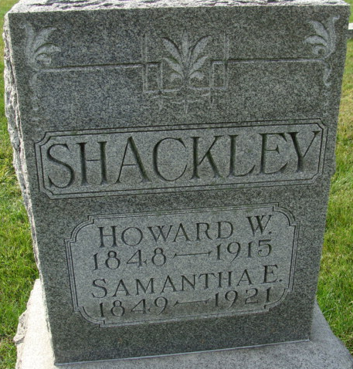
Photo of Alicia Kneuss

Mrs. Samantha Shackley, aged 72, died at the home of a daughter, Mrs. E. R. Johnson, 1012 Putnam Street, at 5:10 o'clock this morning, of heart trouble. She had been ill for the last two years. Mrs. Shackley was a member of the Trinity Methodist Episcopal Church, of this city, and had lived here for the last 10 years.
Surviving are four daughters, Mrs. E. R. Johnson and Miss Jennie Shackley, of this city; Mrs. Ed Spangler and Mrs. Sin Bowers of Decatur, Ind.; one son, Sam Shackley, of Bryan, O.; one brother, Wilson Kern, of North Dakota; six grandchildren and one great-grandchild.
Funeral services will be held from the home of the daughter, at 1012 Putnam Street, at 10:30 o'clock Monday morning, with the Rev. Manford Wright officiating. Burial at Decatur, Ind.

News Sentinel, Allen County, Indiana
Friday, December 23, 1921
**
DECATUR - Mrs. Howard Shackley, 70 years old, a resident of this county until 10 years ago, when she went to Fort Wayne is dead. She leaves 5 grown children.

Indianapolis Star, Marion County, Indiana
December 25, 1921
**
Indiana, U.S., Death Certificates, 1899-2017
Name Samantha J. Shackley
[Samantha J. Kern]
Gender Female
Race White
Age 72
Marital Status Widowed
Birth Date 9 May 1849
Birth Place Ohio
Death Date 23 Dec 1921
Death Place Fort Wayne, Allen, Indiana, USA
Death Registration Date 1921
Father Samuel Kern
Mother Mrs. Knopp
Spouse Howard M. Shackley
Informant Mrs. E. R. Johnson
Burial December 26, 1921; Decatur, Indiana

