Robert Earl Shackley
May 3, 1930 – April 28, 2008

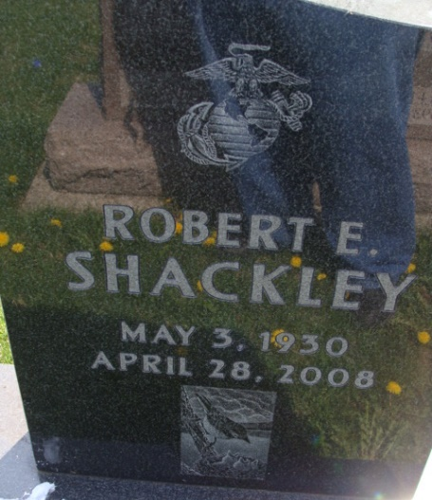
Photo by Alicia Kneuss

Robert E. Shackley, 77, Manassas, Virginia, died in Virginia on April 28. He was a native of Decatur.
Among survivors are a daughter; a son; three sisters: Sue Shackley, Cheryl Morton, and Karen Miller, all of Decatur; and a brother.
His wife, the former Joann Freeman; two sisters; and a brother are deceased.
Burial will be at 11 a.m. this Friday in Decatur Cemetery.

Decatur Daily Democrat, Adams County, Indiana
Wednesday, May 28, 2008
**
Virginia, U.S., Death Records, 1912-2014
Name Robert Earl Shackley
Death Date 28 Apr 2008
Death Place Fairfax, Virginia, USA
**
Robert Earl Shackley in Krick McFarland Family Tree
Father Raymond LeRoy Shackley
Mother Beulah Mildred Beery
Children Robert Earl
Birth 3 May 1930 Indiana, USA
Death 28 Apr 2008 Decatur, Adams, Indiana, USA
Residence 1935 Decatur, Adams, Indiana, USA

