Raymond L. Shackley
November 4, 1902 – October 29, 1964

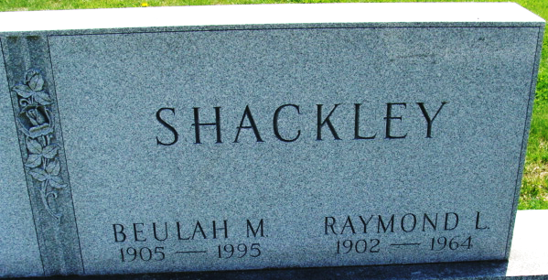
Photo by Alicia Kneuss

Raymond L Shackley
in the Indiana, U.S., Death Certificates, 1899-2017
Name Raymond L Shackley
Gender Male
Race Caucasian (White)
Age 61
Marital Status Married
Birth Date 4 Nov 1902
Birth Place Indiana
Death Date 29 Oct 1964
Death Place Decatur, Adams, Indiana, USA
Death Registration Date 1964
Father William Shackley
Mother Carrie Elzey
Informant Mrs. Raymond Shackley; wife; Decatur, Indiana
Burial October 31, 1964; Decatur Cemetery; Decatur, Indiana

