Mary Kathleen Shackley
June 15, 1926 – March 16, 1992

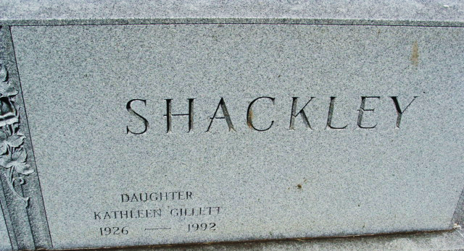
Photo of Alicia Kneuss

Katie was born in Adams County to Raymond & Beulah (Beery) Shackley. She was married to Leo Gillette & was the proud mother to one son & one daughter.
Katie passed away from cancer. She was cremated & buried with her parents.

Unknown source
**
Indiana, U.S., Birth Certificates, 1907-1944
Name Mary Kathleen Schackley
Gender Female
Birth Date 15 Jun 19 26
Birth Place Kirkland, Adams, Indiana, USA
Father Raymond L Schackley; age 23
Mother Beulah N Beery; age 20; 1st child
Certificate Number 27139
Roll number 40474_357778
Volume Range 51 - 55

**
U.S., Social Security Applications and Claims Index, 1936-2007
Name Mary Kathleen Shackley
[Mary Kathleen Gillett]
[Mary Gillett]
Gender Female
Race White
Birth Date 15 Jun 1926
Birth Place Decatur Adam, Indiana
Death Date 16 Mar 1992
Father Raymond L Shackley
Mother Beulah M Beery
SSN xxx
Signature on SSN Card Kathleen Shackley
Relationship of Signature Signature name differs from NH’s name.
Notes Jul 1942: Name listed as MARY KATHLEEN SHACKLEY; Jun 1963: Name listed as MARY KATHLEEN GILLETT; 29 Apr 1992: Name listed as MARY K GILLETT
**
Colorado, Divorce Index, 1851-1985
Name Mary K Gillett
Divorce Date 4 May 1978
Divorce Place Jefferson, Colorado, USA
Spouse Charles L Gillett
Record Type Divorce

