Lori A. Shackley
August 31, 1959 – December 3, 2006

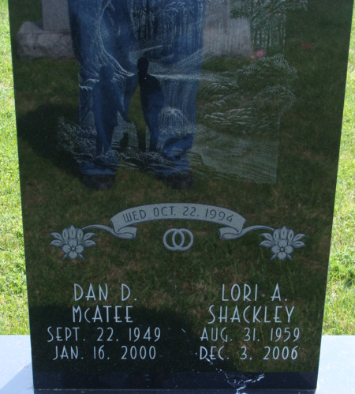
Photo by Alicia Kneuss

DECATUR – Lori A. Shackley, 47, of Decatur, died Sunday, Dec. 3, 2006 at Lutheran Hospital . Born Aug. 31, 1959 in Adams County, the daughter of James K. Shackley and Elizabeth J. "Betty" (Roop). She married Danny D. McAtee Oct. 22, 1994. He preceded her in death on Jan. 16, 2000.
She attended Ivy Tech College for Respiratory Therapist. She was a member of St. Mark's Methodist Church, Decatur.
Surviving is her mother, Elizabeth J. "Betty" Shackley of Decatur; sister, Jana L. Shackley of Decatur; and niece, Lelah Windmiller.
Service is 11 a.m. Thursday at Haggard & Sefton Funeral Home. Visitation is from 4 to 8 p.m. Wednesday at the funeral home. The Rev. Jeff Taylor officiating. Burial in Decatur Cemetery at a later time.
Memorials to A.S.P.C.A. (American Society for the Prevention of Cruelty to Animals).

Haggard & Sefton Funeral Home, Adams County, Indiana
December 4, 2006

