Lilly Blanche Shackley
May 25, 1885 – April 11, 1910

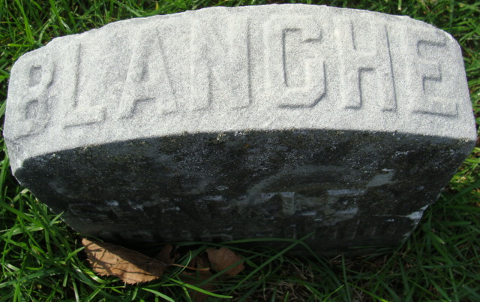
Photo of Alicia Kneuss

Lilly Blanche Shackley
in the Indiana, U.S., Death Certificates, 1899-2017
Name Lilly Blanche Shackley
Gender Female
Race White
Age 24
Marital Status Single
Birth Date 25 May 1885
Birth Place Adams Co Indiana
Death Date 11 Apr 1910
Death Place Decatur, Adams, Indiana, USA
Death Registration Date 1910
Father Howard W. Shackley
Mother Samantha Kern
Informant Samantha Shackley; Decatur, Indiana
Burial April 13, 1910; Decatur Cemetery

