Jana L. Shackley
January 4, 1954 – June 25, 2021

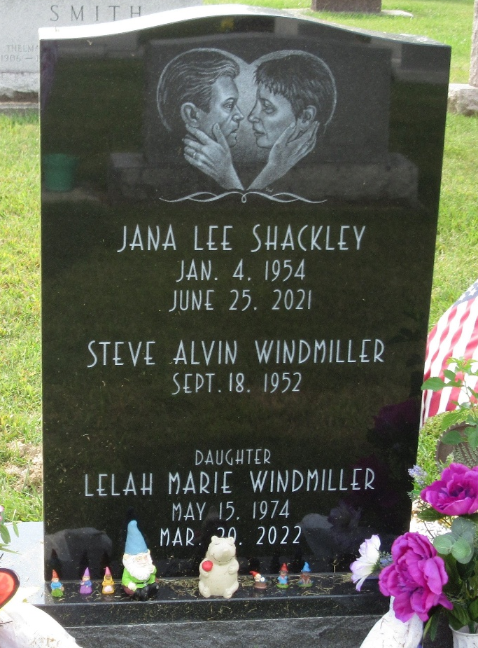
Photo by PLS

Jana L. Shackley, 67, of Decatur, Indiana passed away on the morning of Friday, June 25, 2021, at Adams Memorial Hospital. She was born in Decatur, IN, on January 4, 1954, the daughter of the late James K. and Elizabeth J. “Betty” (Roop) Shackley. On August 26, 1978, she married Steve A. Windmiller.
She was a 1972 graduate of Bellmont High School. Jana worked for the bakery and floral departments at Kroger in Decatur for 15 years. She then went on to Adams Woodcrest, where she worked in housekeeping for over 10 years before retiring 4 years ago.
Jana was an avid reader and genealogist and always strived to further educate herself. She enjoyed gardening and tending to her house plants.
She is survived by her husband of 42 years, Steve Windmiller of Decatur and her daughter, Lelah M. Windmiller of Decatur. She is also survived by her dog, Lizzy and her cat, Sophia. She was preceded in death by her sister, Lori A. Shackley and her brother-in-law, Dan McAtee.
Visitation will be from 4:00 – 8:00 p.m. on Wednesday, June 30, 2021, at Haggard-Sefton-Hirschy & Zelt Funeral Home. Burial will take place next to her family in the Decatur Cemetery at a later date.
Memorials may be made to PAWS of Adams County.

Haggard & Sefton Funeral Home, Adams County, Indiana
Friday, June 25, 2021

