James K. Shackley
October 18, 1928 – June 6, 1993

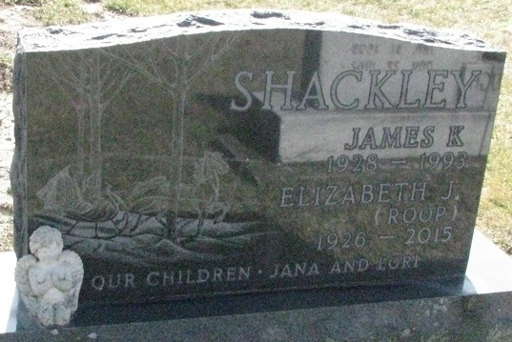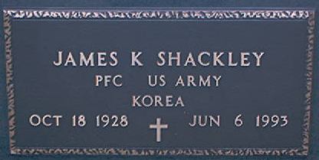
Photo by PLS

James K. Shackley, 64, 103 Windsor Ct., died Sunday in Caylor-Nickel Medical Center, Bluffton. He was born in Adams County on October 18, 1928 to Raymond and Beulah Beery Shackley. His father is deceased; his mother lives in Decatur. He married Elizabeth J. "Betty" Roop on November 26, 1950. She survives.
He retired from Central Soya in Decatur in 1981 after a 35-year career and was a founding partner of Universal Metalcraft in Preble. he was a member of St. Mark's United Methodist Church and American Legion Post 43 in Decatur and was a veteran of the U. S. Army.
Other survivors are two daughters, Jana Lee Shackley, wife of Steve Windmiller, and Lori Anne Shackley, both of Decatur; two brothers, Robert Shackley, Manassas, Virginia, and Daniel Shackley, Spartansburg, South Carolina; four sisters, Charleen Nelson, Bradenton, Florida, and Sue Alice Shackley, Mrs. Alan (Cheryl) Morton, and Mrs. Craig (Karen) Miller, all of Decatur; and a granddaughter. A sister, Kathleen Gillette, is deceased.
Funeral services will be at 11 a.m. Wednesday in Haggard and Armes Funeral Home, Revs. Fuhrman Miller and Lynn Soughan officiating. Burial will be in Decatur Cemetery. Visiting hours are 2-5 and 7-9 p.m. Thursday.

Decatur Daily Democrat, Adams County, Indiana
Monday, June 7, 1993

