Ireta Mae Shackley
June 29, 1911 – January 12, 1969

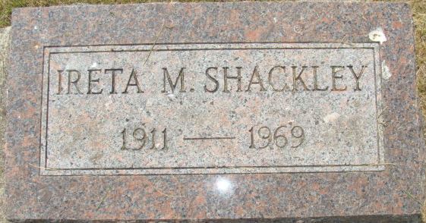
Photo of Alicia Kneuss

Ireta Shackley Dies at Hospital

Miss Ireta Mae Shackley, 57, of 12214 South Anthony Boulevard, Fort Wayne, a native of Adams County, died at 11:30 a.m. Sunday at the Lutheran Hospital, where she was taken after being stricken while shopping Saturday evening.
She was born in Adams County on June 29, 1911, a daughter of William and Carrie Elzey-Shackley. Miss Shackley attended the Lutheran Church in Fort Wayne.
The only survivors are several nieces and nephews. One sister and four brothers are deceased.
Services will be held at 2 p.m. Tuesday at the Winteregg-Linn Funeral Home with Rev. Fuhrman Miller officiating. Burial will be in the Decatur Cemetery. Friends may call at the funeral home after 7 p.m. today until time of the services.

Decatur Daily Democrat, Adams County, Indiana
Monday, January 13, 1969

