Howard Wattson Shackley
December 14, 1848 – February 15, 1915

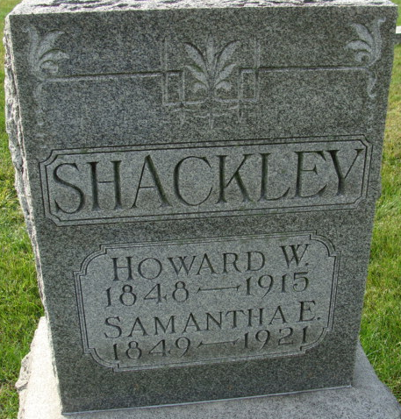
Photo of Alicia Kneuss

Howard Wattson Shackley
in the Indiana, U.S., Death Certificates, 1899-2017
Name Howard Wattson Shackley
Gender Male
Race White
Age 66
Marital Status Married
Birth Date 14 Dec 1848
Birth Place Maine
Death Date 15 Feb 1915
Death Place Washington, Adams, Indiana, USA
Death Registration Date 1910 - 1919
Father Joseph Shackley
Mother Louisa J. Emmonds
Spouse Samantha L.
Informant Samuel Shackley; Decatur, Indiana
Burial February 18, 1915; Decatur Cemetery

**
HOWARD W. SHACKLEY, farmer, section 24, Root Township, came to this county in October, 1851, when he was less than three years old, with his parents and four other children, and settled upon the farm now owned by our subject. There was a small clearing, and a dilapidated log cabin on the place. The house had an old-fashioned chimney that had been torn out, and an ox team could easily have been driven through the aperture. The family lived in that house four years, then the father built the present house. Mr. Shackley's father, Joseph Shackley, was born in York, Maine, January 12, 1792, where he was reared and married, and lived until he immigrated to Indiana, settling in Adams County, where he died September 14, 1875, aged eighty-three years. He was a conscientious and upright man and lamented by all who knew him. He was a member of the Methodist church. He had a great antipathy to horses, and would seldom drive or ride one. He commenced life with nothing, but being industrious and economical, he left an estate worth $7,000. His first wife was Miss Taylor, who died after being married six years. His second wife was Louisa R. Emmonds. They had ten children - Phineas C., Louisa J., who died at the age of fourteen years, Jonas, George, Hiram W., who died when a few weeks old, Hiram Whitehouse, Warren R., Daniel K., Louisa J. and Howard W. The latter was born in York County, Maine, December 14, 1848. He came here with his parents, and Adams County has always been his home since. His mother was also a native of York County, Maine, born May 29, 1806, where she grew to maturity. She was a very industrious women and a great weaver. She was a member of the Baptist church, and she was a devoted Christian. Her death cast a gloom over the entire community.
Our subject was married April 10, 1870, to Miss Samantha E. Kern, who was born in Stark County, Ohio, May 9, 1849. When she was four years old she came to Adams County, with her parents, Samuel and Sophia (Knop) Kern, who settled in St. Mary's Township, four miles east of Decatur, where she lived until her marriage. Her father was born in Cumberland County, Pennsylvania, April 24, 1810, where he was reared and married. He afterward removed to Ohio, where he lived until he came to this county. He died on the farm in St. Mary's Township, April 8, 1875, and is buried in Salem cemetery. He was a wagon-maker by trade, but in later life followed farming. He and his wife were both members of the Evangelical Association. The mother was born in Lancaster County, Pennsylvania, August 27, 1809. Her parents were married November 10, 1836, and had a family of ten children, six of whom are living - Henry C., John W. (deceased), Mary C. died at the age of eight years, Elizabeth (deceased), Margaret A. and Levi (twins), Emerson, Mrs. Shackley, Naomi R. and Wilson C. Levi died at the age of six months. Mr. and Mrs. Shackley have had eight children - Nettie, born April 3, 1871; Effie, born June 2, 1874; Samuel K., born November 14, 1877; Jennie, born March 4, 1880, a twin of Joseph W., who died at the age of three months; Bertha M., born June 29, 1882; Lillie B., born May 25, 1885; Warren B., born September 20, 1872, died January 7, 1877. Mrs. Shackley's grandfather, Henry Kern, died in Wayne County, Ohio. Her grandfather, Christian Knop, died in St. Mary's Township, this county. Her maternal great-grandparents were Joel and Margaret (Dufanderver) Carpenter, her grandmother's maiden name being Catherine Carpenter.

Biographical and Historical Record - Adams and Wells Co. Indiana Lewis Publishing Co. Chicago, IL 1887

