Emily Catherine (Mumma) Shackley
February 29, 1844 – March 15, 1929

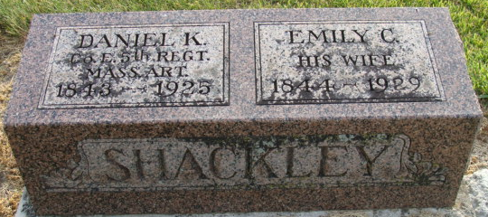
Photo of Alicia Kneuss

Emily Catherine Shackley
in the Indiana, U.S., Death Certificates, 1899-2017
Name Emily Catherine Shackley
[Emily Catherine Mumma]
Gender Female
Race White
Age 83
Marital Status Widowed
Birth Date 29 Feb 1844
Birth Place Ohio
Death Date 15 Mar 1929
Death Place Washington, Adams, Indiana, USA
Death Registration Date 1929
Father John Mumma
Mother Unknown
Informant Wm. Shackley; Decatur, Indiana
Burial March 17, 1929; Decatur Cemetery

**
Indiana, U.S., Marriages, 1810-2001
Name Emily E Muma
Gender Female
Race White
Event Type Marriage Registration (Marriage)
Birth Place Ohio
Marriage Date 5 Nov 1884
Marriage Place Indiana, United States
Residence Place Root Twp, Adams, Indiana
Father John Muma
Mother Catharine Snyder
Spouse Daniel K Shackley
Page 68

