Elizabeth J. “Betty” (Roop) Shackley
December 10, 1926 – June 30, 2015

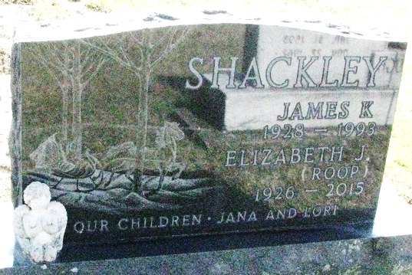
Photo by PLS

Elizabeth J. "Betty" Shackley, 88, Decatur, passed away at her residence Thursday, June 30, 2015. Betty was born in Adams County Dec. 10, 1926, to the late Walter G. and Lelah (Hill) Roop. On Nov. 26, 1950, she married James K. Shackley; he preceded her in death June 6, 1993.
Betty was a member of St. Mark's United Methodist Church. She was a teller for First State Bank, retiring in 1988 after 34 years of service.
Among survivors are her daughter, Jana L. (Steve Windmiller) Shackley of Decatur; and granddaughter, Lelah M. Windmiller of Decatur. She was preceded in death by a daughter, Lori A. Shackley; son-in-law, Danny D. McAtee; and two brothers, Walter and Robert Roop.
Funeral services will be at 10 a.m. Monday at Haggard-Sefton & Hirschy Funeral Home, with Pastor Chris Gadlage officiating. Burial will take place in the Decatur Cemetery. Visitation will be from 12-4 p.m. Sunday at the funeral home and one hour prior to services on Monday.
Preferred memorials are to St. Mark's UMC or Love INC.
Decatur Daily Democrat, Adams County, Indiana
July 3, 2015

