Daniel K. Shackley
March 22, 1843 – October 12, 1925

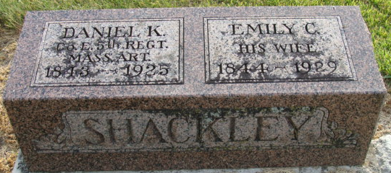
Photo of Alicia Kneuss

Danial K Shackley
in the Indiana, U.S., Death Certificates, 1899-2017
Name Danial K Shackley
Gender Male
Race White
Age 82
Marital Status Married
Birth Date 22 Mar 1843
Birth Place Main
Death Date 12 Oct 1925
Death Place Decatur, Adams, Indiana, USA
Death Registration Date 1925
Father Joseph Shackley
Mother Not known
Spouse Emily
Informant Mrs. Shackley; Decatur, Indiana
Burial October 15, 1925; Decatur Cemetery

**
DANIEL K. SHACKLEY, farmer, owns forty acres of land on section 19, Union Township. He was born in the town of Alfred, York County, Maine, March 22, 1843, and when nine years of age came with his parents, Joseph and Louisa (Emmons) Shackley, to Adams County, who settled on the farm where his brother Howard now lives. Both parents were born in York County, and both are deceased.
Daniel lived at home until 1861, then went to Boston, Massachusetts, where he engaged in teaming for his brother, Phineas Shackley (now deceased), with whom he remained until August 13, 1862, when he enlisted in the Fifth Battery Light Artillery of Massachusetts under Captain Charles E. Phillips. His first service was at Fort Corcoran, Virginia, and from there the captain marched his company to Antietam, Maryland, although the battle had been fought before their arrival. He and four other recruits, one of whom was his brother Jonas, who now lives in Quincy, Massachusetts, joined the battery and followed the Army of the Potomac. He was wounded at Gettysburg, July 3, 1863, in the right lower arm below the elbow, the wound fracturing the bone. He went to Baltimore, thence to Philadelphia, and remained at Chestnut Hill Hospital five months. A part of this time he suffered from lung troubles. From this hospital he went to convalescent camp, at Alexandria, Virginia, and remained five weeks, when he was discharged on surgeon's certificate of disability, January 8, 1864. He then returned to Boston, Massachusetts, and engaged in teaming for different persons until 1869.
In 1866 he was married to Miss Margaret Connor, who was born in Chelsea, Massachusetts, and was about the age of her husband. They had six children - Joseph, Mary C., who died at the age of eleven years; William; Martha, who died at the age of six years; Charles and Ellis G. He came back to Indiana in 1881 and commenced farming.
November 6, 1884, Mr. Shackley was married to Miss Emily C. Mumma, who was born in Tuscarawas County, Ohio, February 29, 1844, and was about seven years old when her parents brought her to this county. Her father, John Mumma, was born in Pennsylvania January 7, 1810, died in September, 1877, and is buried in Pleasant Valley cemetery. The mother, Catherine (Snyder) Mumma, was born in Maryland, March 25, 1811, and is now living with her son, Solomon J. Mumma, of Root Township. There were four children in their family - Solomon J., Eliza J., wife of Robert Kline; Nancy F., wife of William Kline, and Mrs. Shackley who is the youngest. Mr. and Mrs. Shackley are members of the United Brethren church, and in politics Mr. Shackley was formerly a Democrat, but now a Republican.

Biographical and Historical Record - Adams and Wells Co. Indiana Lewis Publishing Co. Chicago, IL 1887

