Carrie Alice (Elzey) Shackley
April 15, 1874 – July 11, 1939

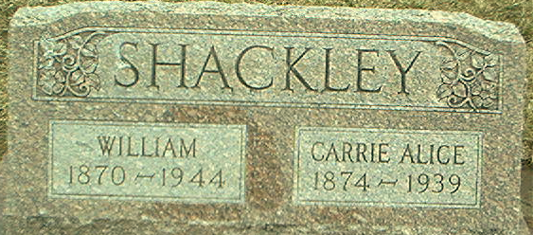
Photo by Alicia Kneuss

SISTER OF DECATUR MAYOR EXPIRES
Funeral for Mrs. William Shackley, Formerly of Berne, is Thursday

Mrs. William Shackley, 65, died of a sudden heart attack Tuesday morning at her home in Decatur. Mr. and Mrs. Shackley formerly resided in Berne. She was born in Root Township.
Surviving besides the husband are the following children: Glenn, of Moline, Ill.; Lloyd and Raymond of Decatur; Earl of Van Wert, O.; Mrs. Mary Katherina Davis and Ireta Schackley of Ft. Wayne; a brother, Forrest Elzey, Mayor of Decatur, and a sister, Mrs. Charles Ulman of Moline, Ill.
Funeral services will be held at the residence, Thursday afternoon at 2:00 o'clock. Burial will be in the Decatur Cemetery.
She was a member of the First U. B. Church at Decatur and for a time taught school at Williams.

The Berne Witness; Adams County, Indiana
Wednesday, July 12, 1939
**
Indiana, U.S., Death Certificates, 1899-2017
Name Carrie Allice Shackley
[Carrie Allice Elzey]
Gender Female
Race White
Age 65
Marital Status Married
Birth Date 15 Apr 1874
Birth Place Indiana
Death Date 11 Jul 1939
Death Place Decatur, Adams, Indiana, USA
Death Registration Date 1939
Father Aquillar Elzey
Mother Mary Butler
Spouse William Shackley
Informant William Shackley; Decatur, Indiana
Burial July 13, 1939; Decatur Cemetery

