Beulah M. (Beery) Shackley
July 30, 1905 – February 21, 1995

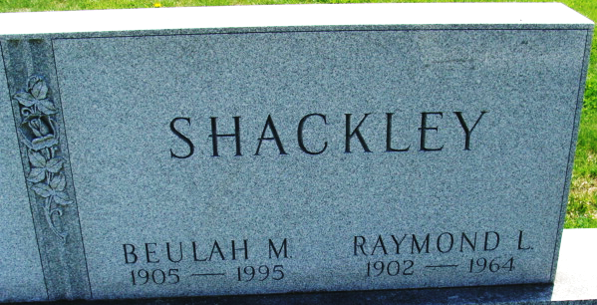
Photo by Alicia Kneuss

Beery
in the Indiana, U.S., WPA Birth Index, 1880-1920
Name Beery
Gender Female
Birth Date 30 Jul 1905
Birth Place Adams, Indiana, USA
Father Harvey Beery
Mother Susie Bright
Book H-8
Page 39

**
Indiana, U.S., Death Certificates, 1899-2017
Name Beulah M Shackley
[Beulah M Beery]
Gender Female
Race White
Age 89
Marital Status Widowed
Birth Date 30 Jul 1905
Birth Place Adams County, Indiana
Death Date 21 Feb 1995
Death Place Decatur, Adams, Indiana, USA
Death Registration Date 1995
Father Harvey Beery
Mother Susie Bright
Informant Sue Shackley; daughter; Decatur, Indiana
Burial February 24, 1995; Decatur Cemetery; Decatur, Indiana

