Edna (Hoffman) Sellemeyer-Blessing
May 5, 1890 – May 16, 1980

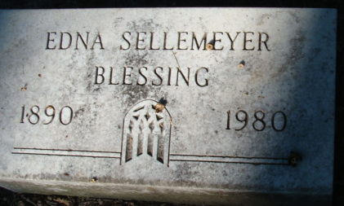
Photo by Alicia Kneuss

Cook County, Illinois Death Index, 1908-1988
Name: Edna Hoffman Blessing
Death Date: 16 May 1980
Death Location: Cook County, IL
File Number: 29496
Archive Collection Name: Cook County Genealogy Records (Deaths)
Archive repository location: Chicago, IL
Archive repository name: Cook County Clerk

**
U.S., Social Security Death Index, 1935-2014

Name: Edna Blessing
SSN: xxxx
Last Residence:
60201 Evanston, Cook, Illinois, USA
BORN: 5 May 1890
Last Benefit: 60201, Evanston, Cook, Illinois, United States of America
Died: May 1980
State (Year) SSN issued: Indiana (Before 1951)

