Sevilla (Kohler) Sellemeyer
November 18, 1859 – September 16, 1917

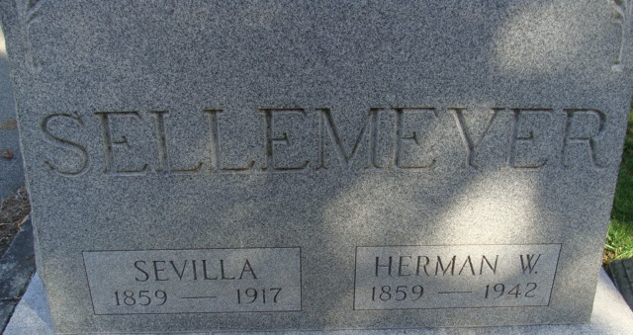
Photo by Alicia Kneuss

Rev. P. S. Kohler returned to Slater, Iowa, after attending the funeral of his sister, Mrs. Herman Sellemeyer.

Fort Wayne Weekly Sentinel, Allen County, Indiana
September 21, 1917

**
Indiana, Death Certificates, 1899-2011
Name: Sevilla Sellemeyer [Sevilla Kohler]
Gender: Female;
Race: White
Age: 57
Birth Date: 18 Nov 1859
Birth Place: French
Death Date: 16 Sep 1917
Death Place: Washington, Adams, Indiana, USA
Father: John P Kohler
Mother: Mary Ann Kohler
Spouse: Herman William Sellemeyer
Burial: 9/18/1917, Decatur Cemetery

