Matilda C. Sellemeyer
August 3, 1887 – April 13, 1976

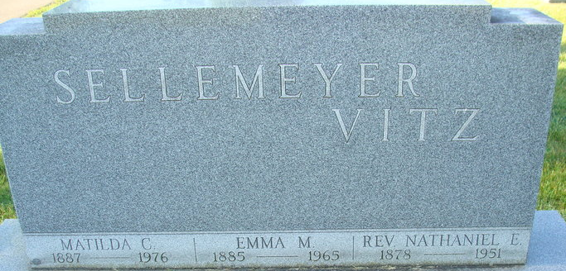
Photo by Alicia Kneuss

Matilda C. Sellemeyer
in the Indiana, U.S., Death Certificates, 1899-2017
Name Matilda C. Sellemeyer
Gender Female
Race White
Age 88
Marital Status Never Married (Single)
Birth Date 3 Aug 1887
Birth Place Indiana
Death Date 13 Apr 1976
Death Place Decatur, Adams, Indiana, USA
Death Registration Date 1976
Father Herman Sellemeyer
Mother Sevilla Kohler
Informant Mrs. Ralph Yager; sister; Decatur, Indiana
Burial April 16, 1976; Decatur Cemetery; Decatur, Indiana

