Marie Mabel (Beery) Sellemeyer
May 17, 1889 – July 18, 1967

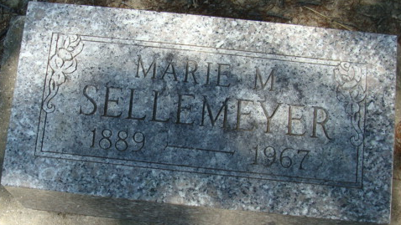
Photo by Alicia Kneuss

California Death Index, 1940-1997
Name: Marie M Sellemeyer
Social Security #: xxx
Sex: Female
Birth Date: 17 May 1889
Birthplace: Indiana
Death Date: 18 Jul 1967
Death Place: Riverside
Mother's Maiden Name: Hower

**
Mabel Marie Beery in The Hoover/Milroy Family Tree
Spouse Jesse O Sellemeyer
Father Daniel W Beery
Mother Mary Etta Hower
Children Martha
Birth 17 May 1889 Adams, Indiana, USA
Death 18 Jul 1967 California, USA
Residence 1955 Monrovia, Los Angeles, California, USA

