Jesse O. Sellemeyer
May 22, 1885 – February 4, 1974

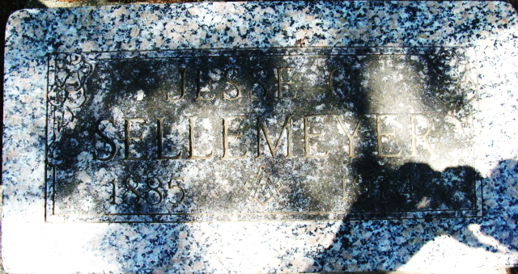
Photo by Alicia Kneuss

J. O. Sellemeyer Dies

Jesse O. Sellemeyer, 88, of Sun City, California, former Decatur businessman, died at 8 p.m. Monday at Hemet Valley Hospital, Hemet, California, where he had been hospitalized one week.
Mr. Sellemeyer, a resident of Sun City for the last 15 years visited Decatur on many occasions during recent years.
He was the oldest member of the Decatur Zion United Church of Christ and lived in the home which is now the parsonage of the church, located at Third and Jackson Streets. He moved to Los Angeles in 1922 and returned to Decatur in the 1950’s, where Mr. and Mrs. Sellemeyer celebrated their 50th wedding anniversary in 1958.
Mr. Sellemeyer was a member of the Decatur Lodge 571 F. &A.M. Scottish Rite, and Shrine, and was the oldest living member of the Decatur Elks Lodge. He was the second President of the Decatur Rotary Club. He attended Decatur High School and won a varsity letter in football at Oberlin College in Ohio and was an avid sports fan.
In his early adult life, Mr. Sellemeyer was a partner in Kirsch-Sellemeyer Lumber Co and was associated with the late Fred Reppert as secretary of the old Adams County Fair and worked with the Reppert Auction School for many years. he retired from the Southwestern Portland Cement Co. in 1950.
Born in Decatur on May 22, 1885, he was the son of August H. And Sarah Langenbacher-Sellemeyer, and was married on September 22, 1908, to Marie M. Beery, who died on July 18, 1967.
Survivors include one daughter, Mrs. Martha Warner of Sun City and one sister, Miss Esther Sellemeyer, of Redlands, California. Several cousins reside in the Decatur area.
Funeral services will be held at 1:30 p.m. Monday at the Zion United Church of Christ, with Rev. William C. Feller and Rev. Howard Beer officiating. Burial will be in the Decatur cemetery. Friends may call at the Winteregg-Linn and Haggard Funeral Home from 10 a.m. Sunday until 11 a.m. Monday, and then at the church from 12 noon until time of the services.

Decatur Daily Democrat, Adams County, Indiana
Wednesday, February 6, 1974

**
Services are Monday for Mr. Sellemeyer

Funeral services for Jesse O. Sellemeyer, 88, of Sun City, California, a former Decatur resident will be held at 1:30 p.m. Monday at the Zion United Church of Christ, with Rev. William C. Feller and Rev. Howard Beer officiating. Burial will be in the Decatur Cemetery. He died last Monday in California.
Pallbearers will be Lawrence Rash, Wayne Burger, Wesley Lehman, Robert Yost, Rufus Kirchhofer and Ron Gerber.
Friends may call at the Winteregg-Linn and Haggard Funeral Home from 10 a.m. Sunday until 11 a.m. Monday, and then at the church from 12 noon until time of the services.

Decatur Daily Democrat, Adams County, Indiana
Friday, February 8, 1974

