Herman W. Sellemeyer
July 14, 1859 – October 8, 1942

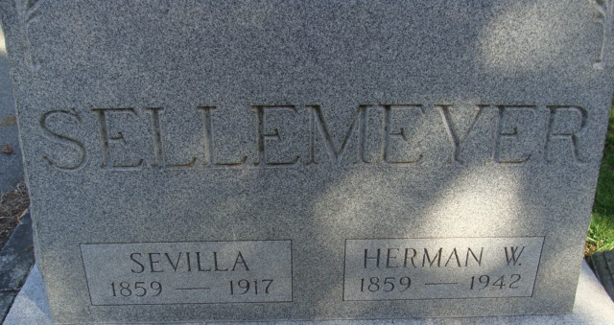
Photo by Alicia Kneuss

Herman Sellemeyer Dies This Morning
Prominent Retired Farmer Dies Today
Herman W. Sellemeyer, 83, prominent farmer died today. He was born July 14, 1859, the son of Ernest and Christine Oetting-Sellemeyer. His wife, the former Sevilia Kohler died September 16, 1917.
Mr. Sellemeyer was the oldest charter member of Zion Evangelical and Reformed Church of this city. He served as deacon for many years and also was trustee and treasurer of the church. He was confirmed by Rev. William Spiess at Magley Church in 1874. He lived in Washington Township until 1918, when he moved to Decatur.
Surviving are three daughters, Mrs. Emma Vitz, of New Bremen, Mrs. Ames Yager of Decatur (other daughter’s name cut off); seven grandchildren and two great grandchildren. Mrs. Hulda Poling of the South of Decatur was reared in the Sellemeyer home. Three children, one sister and three brothers are deceased.
Funeral services will be held at 2 pm Saturday at the Zwick Funeral Home and at 2:30 o’clock at the church, Rev. L. W. Stolte of Dayton, O., officiating. Burial will be in the Decatur Cemetery. The body may be viewed at the funeral home after 7 o’clock this evening.

Decatur Daily Democrat, Adams County, Indiana
Thursday, October 8, 1942
**
HERMAN W. SELLEMEYER
Herman W. Sellemeyer is a native of Adams County, having been born in Preble township July 14, 1859. He was the fifth in order of birth of a family of six children born to his parents, Ernst and Christina (Oeting) Sellemeyer. His father was born in Germany in 1812 and died in 1891. His mother is still living with one of her sons and has reached the advanced age of eighty-nine years. The children of the elder Sellemeyer who are living are: Louise, William, who operates the homestead; Frederick, a resident of Decatur ; H. W., the subject of this sketch, and August, a lumberman. The boyhood home of Mr. Sellemeyer was on his father's farm. He attended the schools of the district and picked up as complete and satisfactory an education as the times and conditions permitted. In the summer months he worked on his father's farm and learned the lessons that agriculture teaches. He was an industrious boy and mastered the principles that he applied to his credit and financial success later in his life.
The marriage of Mr. Sellemeyer and Miss Savilla Kohler was celebrated April 17, 1884. The bride was a daughter of John P. and Mary Ann (Steiner) Kohler. Her father was a native of Switzerland, from which country he came to the United States early in the last century. Mrs. Sellemeyer was one of a family of eleven children born to her parents. Of this large family Peter and Mrs. Sellemeyer are living. William, John, Philip, Celestina, Calvin, Mary, Josephine, Daniel and Edward are dead. John Kohler after coming to America located for a time in the east. Later he moved to Wayne County, Ohio, where he lived and farmed for about five years.
In 1858 he disposed of his Ohio place and moved with his family to Indiana. He purchased land in French Township, Adams County, and continued to farm. In addition to his work on the farm he followed his trades of mason and plasterer and added to his income each year through the medium of the work he did for various farmers of the township. His wife lived on the Indiana homestead and was a faithful and able helpmate to her husband until her demise. She died in 1890. After the death of his wife Mr. Kohler lived, with his daughter and Mr. Sellemeyer until his own death, March 9, 1900. He was one of the most highly respected men of the township and his life had been of great benefit to the community in which he lived.
Mr. and Mrs. Sellemeyer are the parents of three children, all of whom are living. The eldest, Emma, is one of the best-known educators of Adams County. She is a woman of much initiative and has had a most
successful career as a teacher. At present she is teaching in the primary grades of the public schools at Decatur. A second daughter, Matilda, is also a teacher and is at present one of the teachers at the Preble school in Preble Township. Agnes, the youngest daughter, is attending the schools of her home district. In addition to his three daughters Mr. Sellemeyer has given a home and a parent's consideration and affection
to Hulda Bauer.
The estate owned by Mr. Sellemeyer consists of seventy-five acres, all well improved and at a high stage of fertility and productiveness. He has practically made all of the improvements on his place without outside aid. He has lived on it continuously for twenty-one years. Two years of his life he spent working in a sawmill in Decatur before coming to his present farm. He takes an interested part in the affairs of his community. He is a member of the Democratic Party but has never held or aspired to public office. He and his wife are members of the German Reformed Church at Decatur and are earnest supporters of this denomination.

Snow's History of Adams County, Indiana, John Fletcher Snow, B. F. Bowen, Indianapolis, IN, 1907.

