Esther Irene Sellemeyer
May 24, 1892 – January 6, 1979

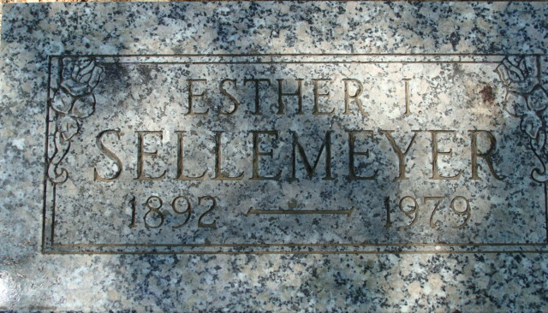
Photo by Alicia Kneuss

Sellmeyer
in the Indiana, U.S., WPA Birth Index, 1880-1920
Name Sellmeyer
Gender Female
Birth Date 24 May 1892
Birth Place Adams, Indiana, USA
Father August Sellmeyer
Mother S Longenbacher
Book H-2
Page 37
**
California, U.S., Death Index, 1940-1997
Name Esther Irene Sellemeyer
Social Security # xxx
Gender Female
Birth Date 24 May 1892; Birth Place Indiana
Death Date 6 Jan 1979; Death Place San Bernardino
**
U.S., Passport Applications, 1795-1925
Name Esther Irene Sellemeyer
Age 30
Birth Date 24 May 1892
Birth Place Decatur, Indiana
Residence Place Decatur, Indiana, US
Passport Issue Date 30 Mar 1923
Father August H Sellemeyer
Has Photo Yes
Was missionary in China from Sept. 1917 - June 1918
Certificate Number 261649

