Elizabeth (Miller) Sellemeyer
August 14, 1855 – October 24, 1932

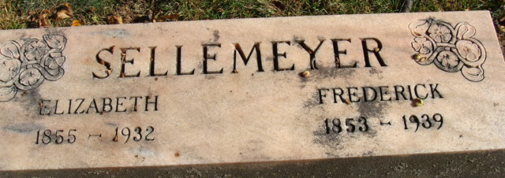
Photo by Alicia Kneuss
SELLEMEYER RITES HELD

Decatur, Oct. 27 – Funeral services for Mrs. Frederick Sellemeyer, 77, lifelong resident of Adams County, who died at her home, 329 North Fourth Street Monday night, were held this afternoon at 2 o'clock at the home and at 2:30 o'clock from the Zion Reformed Church, Rev. David Grether, assisted by Dr. Rupnow officiated. Burial was made in the Decatur Cemetery.

The Berne Review; Adams County, Indiana
Thursday, October 27, 1932

**
Indiana, U.S., Death Certificates, 1899-2017
Name Elizabeth Miller Sellemeyer
[Elizabeth Miller Miller]
Gender Female
Race White
Age 77
Marital Status Married
Birth Date 14 Aug 1855
Birth Place Preble Twp Indiana
Death Date 24 Oct 1929 [sic]
Death Place Decatur, Adams, Indiana, USA
Death Registration Date 1932
Father Adam Miller
Mother Mary Poling ??
Spouse Frankin Sellemeyer
Informant Mrs. Fred Heuer; Decatur, Indiana
Burial October 27, 1932; Decatur Cemetery

