Catherine Elizabeth Sellemeyer
June 2, 1917 – August 2, 1923

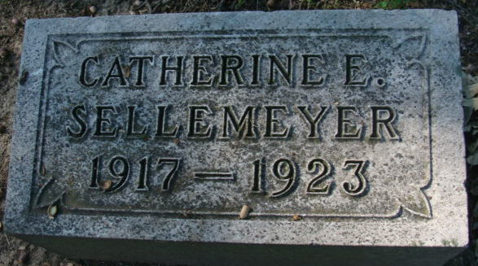
Photo by Alicia Kneuss

SELLEMEYER GIRL IS DEAD
Catherine Sellemeyer, Popular Little Girl, Dies at Fort Wayne Today

Catherine Elizabeth Sellemeyer, 6-year-old daughter of Mr. and Mrs. Albert Sellemeyer, died at 2:30 o'clock this afternoon at the St. Joseph Hospital in Fort Wayne, of ptomaine poisoning. The news of her death was conveyed to relatives here over the telephone.
Little Miss Catherine was one of the most charming and talented girls of her age in Decatur and was known to nearly everyone in the city, having taken part in public entertainment many times. She was the only child of Mr. and Mrs. Sellemeyer. She attended the fair last week and became poisoned by something which she ate on the fair grounds it is thought. She took sick on Friday night and her condition grew worse until she was taken to the Fort Wayne hospital at midnight on Monday night. The best medical attention possible was given her in an effort to save her life.
The remains will be brought back to the home on North Fifth Street this evening. Funeral arrangements will be announced later.

Decatur Daily Democrat, Adams County, Indiana
Thursday, August 2, 1923
**
FUNERAL TO BE HELD AT HOME
Services For Little Catherine Sellemeyer at 3 P.M. Saturday
Funeral services for little Catherine Sellemeyer, six-year-old daughter of Mr. and Mrs. Albert Sellemeyer, whose death occurred Thursday afternoon at Fort Wayne, will be held at three o’clock Saturday afternoon from the residence on North Fifth Street, Rev. R. R. Elliker, of the Reformed Church, officiating. Interment will be made in the Maplewood Cemetery. The body may be viewed by friends from seven thirty until nine thirty this evening.
The whitened and lifeless little body of the child who was the flower and joy of the now grief stricken parents, lies in a crimson casket buried under a bed of roses, lilies and beautiful flowers, expressions of love and admiration from the many friends of little Catherine Sellemeyer.
The physicians pronounced the cause of death as resulting from Ile colitis, a form of inflammation of the bowels, brought about by eating poisonous food. Catherine and her parents attended the fair last week and she became ill on Friday, presumably after eating or drinking something on the grounds. Her condition became worse Monday and she was taken to the St. Joseph Hospital, Fort Wayne, where everything possible was done to save her life, but her frail little body could not fight off the poisonous attack that had already settled its grip upon her, death relieving her Thursday afternoon.
Decatur Daily Democrat, Adams County, Indiana
Friday, August 3, 1923

**
Indiana, Death Certificates, 1899-2011
Name: Catherine Elizabeth Sellemeyer
Gender: Female
Race: White
Age: 6
Marital status: Single
Birth Date: 2 Jun 1917
Birth Place: Decatur
Death Date: 2 Aug 1923
Death Place: Ft Wayne, Allen, Indiana , USA
Father: Albert Sellemeyer
Mother: Edna Hoffman
Informant: Bertha Heuss?; Decatur, Indiana
Burial: August 5, 1923; Decatur Cemetery

