Albert M. Sellemeyer
November 3, 1886 – February 20, 1955

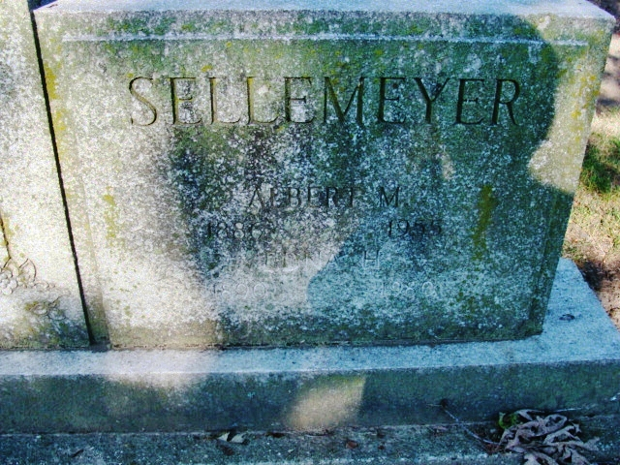
Photo by Alicia Kneuss

Handwritten-Wed. 1955

RITES TODAY FOR ALBERT SELLEMEYER
RETIRED DIRECTOR OF DECATUR HIGH SCHOOL BAND DIES

Decatur, Feb. 23.—Albert M. Sellemeyer, 68, retired Decatur High School band leader and teacher, and one of the city’s best known citizens, died at 4 o’clock Sunday afternoon at the Ohio State University Hospital at Columbus, Ohio.
Mr. Sellemeyer, who had been in ill health for several years, had been a patient at the Columbus Hospital for the last four ?? (Missing)
Mr. Sellemeyer retired at the end of the school year in May of 1951 after serving 26 years as band instructor and assistant teacher in the Decatur Public Schools.

Adams County (IN) Historical Museum
1955 Feb – Apr Scrapbook, image 06-08
*****

U.S., Social Security Applications and Claims Index, 1936-2007
Name: Albert M Sellemeyer
Birth Date: 3 Nov 1886
Claim Date: 18 Oct 1951
SSN: xxx
Notes: 17 Oct 1951: Name listed as ALBERT M SELLEMEYER

