Sylvester “Bud” Sell
March 20, 1936 – October 10, 2017

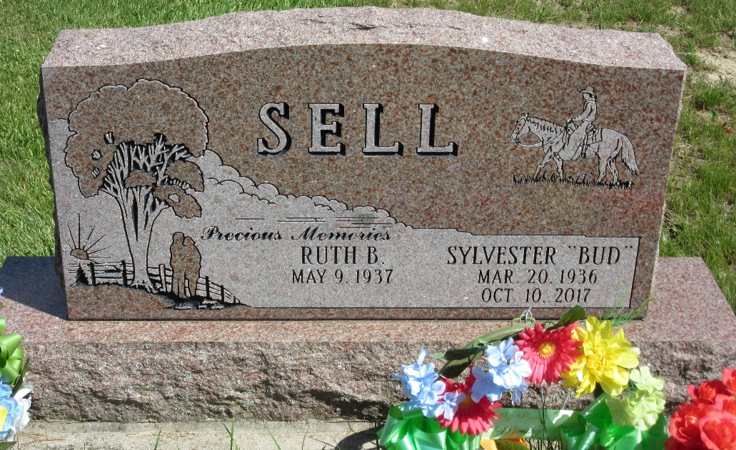
Photo by PLS

Sylvester "Bud" Sell, 81, of Pennville, IN, passed away at 6:00 PM on Tuesday, October 10, 2017 at his residence in Pennville, IN. He was born on Friday, March 20, 1936, in Decatur, IN. Bud attended the Geneva Elementary Schools and Decatur Schools. He worked with horses and also built horse trailers. He was very well known in the Amish community. Bud attended the Geneva Nazarene Church. He was a maintenance worker for South Adams Schools for 26 years before retiring in 1997. He enjoyed going to auctions and wrestling.
Loving Survivors Include his Daughters Anita (Husband-Mike) Faller, Geneva, IN, Jeanette (Husband-Jim) Truppi, Ridgeville, IN, Nancy Armstrong, Geneva, IN, Daughter - Tammy (Jeff) Hutchens, Four Oaks, NC, Sons - Tim (Wife-Sabra) Sell, Pennville, IN, Randy Sell, Bryant, IN, Jim (Wife-Cheryl) Sell, Portland, IN, David Aveline, West Lafayette, IN, Sisters - Frances Fifer, Ft. Wayne, IN, Gladys Huth, Ft. Wayne, IN, Juanita Dillon, Ft. Wayne, IN, Martha Ball, Decatur, IN, Brothers - Ralph Sell, TX, Eddy Sell, Bryant, IN, 26 Grandchildren, and 28 Great Grandchildren.
He was preceded in death by his Father - Ora Sell, Mother - Ruth (Smith) Sell, Sister - Irene Cripe, and Sister - Mary Schick.
Family and friends may gather to share and remember at Downing & Glancy Funeral Home 100 N Washington Street Geneva on Friday, October 13, 2017 from 4:00 PM to 8:00 PM. A service to celebrate his life will be at Downing & Glancy Funeral Home at 11:00 AM on Saturday, October 14, 2017 with Mark Hinshaw and Alan Crull officiating. Interment will follow in the Decatur Cemetery in Decatur.
Preferred memorials: Donor's Choice.

Downing & Glancy Funeral Home, Adams County, Indiana
October 12, 2017

