Nolan G. Sell
May 25, 1912 – September 20, 2006

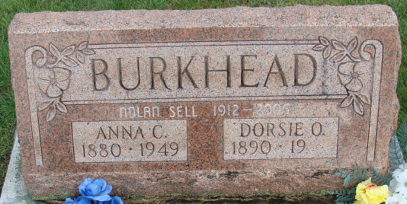
Photo by Alicia Kneuss

Nolan G. Sells, 93, of Indianapolis, Indiana formally of Decatur, Indiana passed away Wednesday, September 20, 2006 at Briarwood Health Care & Rehabilitation Center in Indianapolis, Indiana.
Nolan was born on May 25, 1912 in Georgetown AK to Eli Orwen & Ida (Parsons) Sell. His parents are deceased.
Nolan is survived by three brothers; Ralph (Barbara) Sell of Magnolia, Texas, Bud (Ruth) Sell of Pennville, Indiana, Eddie (Shadow) Sell od Birch Tree, Mo; six sisters; Irene Cripe of Kalamazoo, Michigan, Mrs. Donald (Frances) Fifer, Mrs. Fred (Mary) Schick, Mrs. Leonard (Gladys) Huth, Mrs. Bobby (Juanita) Dillion all of Fort Wayne, Indiana, and Mrs. Logan (Martha) Ball of West Liberty, Kentucky.
Visitation will be from 10-11 a.m. on Saturday, September 23, 2006 at Haggard & Sefton Funeral Home, followed by a 11:00 a.m. Funeral also at the funeral home on Saturday. Rev. Wayne Gullion will be officiating and burial is in Decatur Cemetery.
Haggard-Sefton Hirschy Funeral Home, Adams County, Indiana
September 21, 2006

