Lisa Ann Sell
September 30, 1966 – February 3, 1972

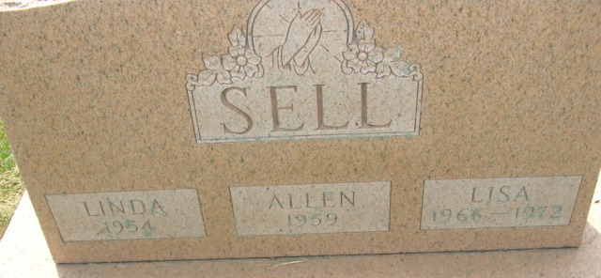
Photo by Alicia Kneuss

Geneva Girl, 5, Dies of Burns
A five-year-old Geneva girl, Lisa Sell, died early Thursday morning at the Riley Hospital in Indianapolis, of burns suffered in a fire at the home of her parents on Geneva route 1. The child, daughter of Mr. and Mrs. Sylvester Sell, had been burned over 70 percent of her body Jan. 18, where her clothing was ignited from a heating stove in her home.
The little girl was born in Decatur Sept. 30, 1966, a daughter of Sylvester (Bud) and Hazel Clark-Sell.
Surviving in addition to the parents are three sisters, Anita, Jeannette and Nancy, and three brothers, Timmie, Randy and Jimmie, all at home, and grandparents, Mr. and Mrs. Grover Alberson of Geneva, and Arthur Clark of Angola.
Funeral rites will be held at 2 p.m. Saturday at the Church of the Nazarene in Geneva, with Rev. Kenneth Whitescarver officiating. Burial will be in the Decatur Cemetery. Friends may call at the Hardy & Hardy Funeral Home in Geneva after 5 p.m. today and at the church from noon Saturday.

Decatur Daily Democrat, Adams County, Indiana
Friday, February 4, 1972
**
Indiana, Death Certificates, 1899-2011
Name: Lisa Ann Sell
Gender: Female; Race: White;
Age: 5
Marital Status: Never Married (Single)
Birth Date: 30 Sep 1965
Birth Place: Indiana
Death Date: 2 Feb 1972
Death Place: Indianapolis, Marion, Indiana, USA
Father: Sylvester H Sell
Mother: Hazel Clark
Cause of death: 70% 3rd degree burns; climbed on stove & caught clothing on fire
Burial: 2/5/1972, Decatur City Cemetery

