Linda Kay Sell
September 14, 1954 – December 3, 1954

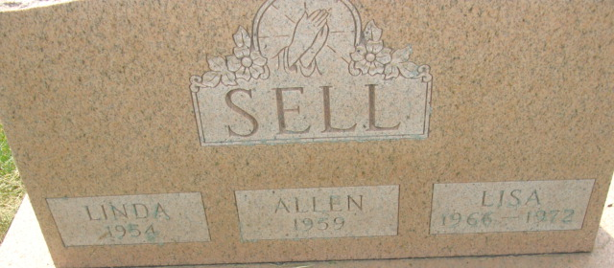
Photo by Alicia Kneuss

Linda Kay Sells
in the Indiana, U.S., Death Certificates, 1899-2017

Name Linda Kay Sells
Gender Female
Race White
Age
Birth Date 14 Sep 1954
Birth Place Decatur Indiana
Death Date 3 Dec 1954
Death Place Decatur, Adams, Indiana, USA
Death Registration Date 1954
Father Sylvester Sells
Mother Hazel Clark
Informant Sylvester Sells; Decatur, Indiana
Burial December ?, 1954; Decatur Cemetery

