Judy Ann (Burnside) Sell
March 9, 1947 – May 7, 1980

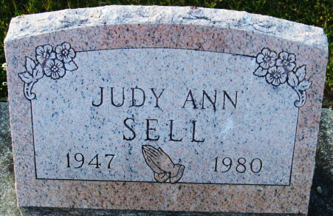
Photo by Alicia Kneuss

Judy Ann Sell
in the Indiana, U.S., Death Certificates, 1899-2017
Name Judy Ann Sell
[Judy Ann Burnside]
Gender Female
Race White
Age 33
Marital Status Married
Birth Date 9 Mar 1947
Birth Place Missouri
Death Date 7 May 1980
Death Place Portland, Jay, Indiana, USA
Death Registration Date 1980
Father Unknown Burnside
Mother Sarah
Spouse Sylvester Sell
Informant Sylvester Sell; Portland, Indiana
Burial May 10, 1980; Decatur Cemetery; Decatur, Indiana
**
Judy Ann Sell from tree Jones Family Tree
Birth 9 Mar 1947 Arkansas, USA
Marriage 1963 Arkansas, USA
Death 7 May 1980 Portland, Jay, Indiana, USA
Father John M Gramm (1903-1988)
Mother Sarah Burnside (1910-1996)
Spouse Larry Lee Jones (1941-2002)

