Hiram Perry Sell
May 16, 1846 – 1909

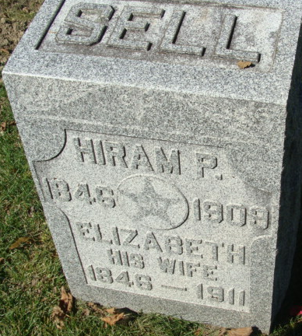
Photo by Alicia Kneuss

Hiram Perry Sell from tree Marble Family Tree
Birth 16 May 1846 Bellville, Richland, Ohio, USA
Marriage 12 Feb 1867 Richland, Allen, Ohio, USA
Residence 1900 Adams, Indiana, USA
Death 1909
Father Henry Sell (1810-1898)
Mother Catherine Jackson (1814-1887)
Spouse Elizabeth A. McLAUGHLIN (1846-1911)

