Hazel (Clark) Sell
September 7, 1936 – August 10, 2002

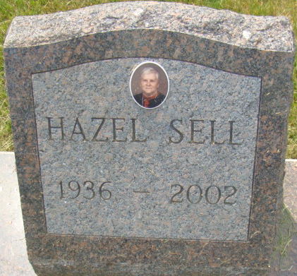
Photo by Alicia Kneuss

Hazel Sell, 66, died Saturday at Chalet Village, Berne. Born in Bluffton, she was a homemaker. Surviving are three sons, Tim and Randy of Pennville and Jim of Portland; four daughters, Anita Faller and Nancy Armstrong both of Geneva, Jeanette Truppi of Van Wert, Ohio and Tammy Hutchens of Pennville; four sisters, Nina McGinnes and Susie Stoner, both of Fort Wayne, Wande Gephart of Portland and Helen Wilson of Huntington; 21 grandchildren; and four great-grandchildren.
She was preceded in death by two daughters, Linda Sell and Lisa Ann Sell and a son, Allen Sell.
Services at 10 a.m. Wednesday at Williamson & Spencer Funeral Home, Portland Chapel. Calling from 4 to 6 p.m. Tuesday. Burial in Decatur Cemetery.

Journal Gazette, Allen County, Indiana
Monday, August 12, 2002
**
Indiana, U.S., Death Certificates, 1899-2017
Name Hazel Sell
[Hazel Clark]
Gender Female
Race White
Age 65
Marital Status Divorced
Birth Date 7 Sep 1936
Birth Place Bluffton, Indiana
Death Date 10 Aug 2002
Death Place Berne, Adams, Indiana, USA
Father Arthur Clark
Mother Minnie Jackson
Informant Nancy Armstrong; daughter; Geneva, Indiana
Burial August 14, 2002; Decatur Cemetery; Decatur, Indiana

