Elizabeth (McLaughlin) Sell
September 1, 1846 – July 8, 1911

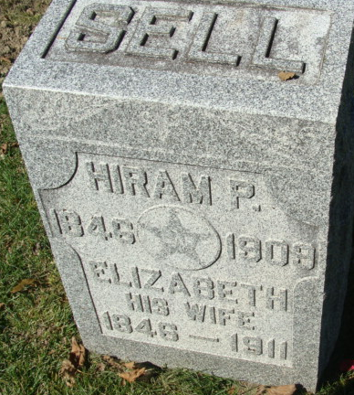
Photo by Alicia Kneuss

Elizabeth Sell
in the Indiana, U.S., Death Certificates, 1899-2017
Name Elizabeth Sell
[Elizabeth McGblon]
Gender Female
Race White
Age 54
Marital Status Widowed
Birth Date 1 Sep 1846
Birth Place Widowed
Death Date 8 Jul 1911
Death Place Decatur, Adams, Indiana, USA
Death Registration Date 1911
Father McGhlon [sic]
Mother Thompson
Informant Eli Sell; Decatur, Indiana
Burial July 11, 1911; Decatur Cemetery

