Elie Ora Sell
November 15, 1867 – October 12, 1953

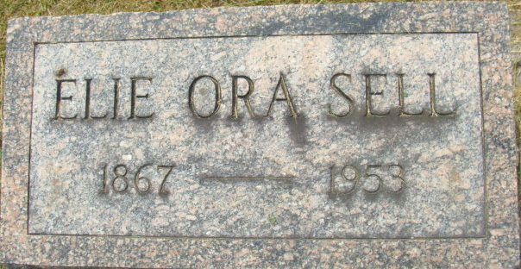
Photo by Alicia Kneuss

Eli Orwin Sell
in the Indiana, U.S., Death Certificates, 1899-2017
Name Eli Orwin Sell
Gender Male
Race White
Age 85
Marital Status Married
Birth Date 15 Nov 1867
Birth Place Mercer Co Ohio
Death Date 12 Oct 1953
Death Place Decatur, Adams, Indiana, USA
Death Registration Date 1953
Father Harmon Sell
Mother Elizabeth McLaughlin
Informant Mrs. E. O. Sell; Decatur, Indiana
Burial October 15, 1953; Decatur Cemetery; Decatur, Indiana

