Allen Sell
1959 - 1959

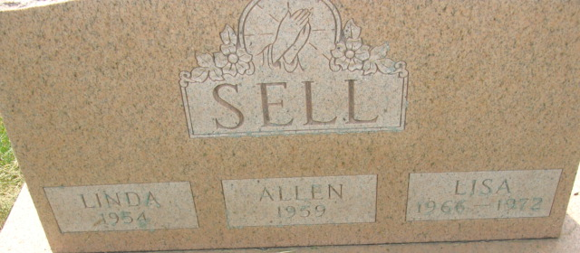
Photo by Alicia Kneuss

Allen Sell from tree Albanese/Lee Family Tree
Birth 1959 Indiana, USA
Death 1959 Indiana, USA
Father Sylvester Hiram "Bud" Sell (1936-2017)
Mother Hazel Clark (1936-2002)

