Winston Wisel Seitz
June 19, 1926 – October 21, 1989

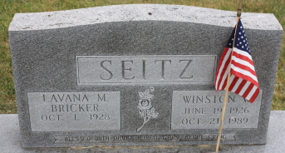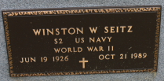
Photo by James Sheets

Winston W Seitz
in the Indiana, U.S., Death Certificates, 1899-2017
Name Winston W Seitz
Gender Male
Race White
Age 63
Marital Status Married
Birth Date 19 Jun 1926
Birth Place Putman County, Ohio
Death Date 21 Oct 1989
Death Place Fort Wayne, Allen, Indiana, USA
Death Registration Date 1989
Father Charles E Seitz
Mother Beulah M Wood
Spouse Lavana
Informant Mrs. Lavana Seitz; wife; Decatur, Indiana
Burial October 24, 1989; Decatur Cemetery; Decatur, Indiana

