Vernon D. Seitz
April 20, 1929 – April 12, 2023

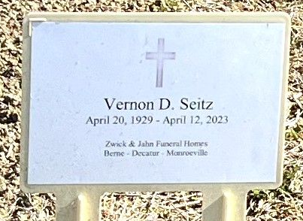
Photo of Deb Curry

Vernon (Vern) D Seitz, of Decatur, passed away peacefully at home on April 12, 2023. Vernon was born at home, in Rimer, Ohio to the late Charles and Beaulah (Wood) Seitz (Burgett).
He graduated from Van Wert High School in 1947. He also graduated from Purdue Technical Institute with an associate degree in electrical technology. He enlisted in the US Navy from 1948 - 1952, and was honorably discharged. While in the Navy, his military occupation was a radio operator. This continued and applied to his future hobby in “Amateur Radio”, which he became interested in while in high school. He was proud to be a lifelong Amateur Radio Operator (Ham Radio) using the call sign “W9HLY”.
He married the love of his life, Carol A Baumgartner, on October 16, 1955, at the First Baptist Church of Decatur, and was married to her for 67 years.
He was employed by the Magnavox Company (later Raytheon) as an electrical engineer in electronic warfare.
Vernon enjoyed spending time in his “Ham Shack”, tending to his yard and pulling weeds, and spending time with his wife, daughters and son, and his beloved grandchildren.
He is survived by his wife, Carol Seitz, daughter Janice (Seitz) Adler, daughter Sandra (Seitz) Ridgeway (companion Michael). Grandchildren, Spencer Myers (fiancé Lauren Johnson), Marissa Aguon (husband Anthonie), Vincent Myers (wife Brianna) and McKenzie Bussel (husband Cole). Great grandchild Vivian Myers and baby Bussel expected in October 2023. He is also survived by sister Janet (Seitz) Evans.
He was preceded in death by his son, Steven D Seitz, brothers Raymond Seitz and Winston Seitz, sisters Carol (Seitz) Aurand and Winifred (in childhood).
Per Vernon's and the family's request, there will be private services with burial following at Decatur Cemetery.
Memorials can be made to the Adams County Historical Society.

Zwick & Jahn Funeral Home, Adams County, Indiana
April 13, 2023

