Lavana M. (Bricker) Seitz
October 1, 1928 -

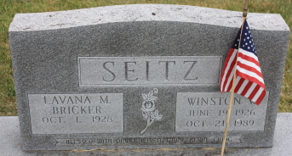
Photo by James Sheets

Indiana Marriages, 1811-2019

Name Winston Wisel Seitz
Birth Date 19 June 1926; Birthplace Putnam, Ohio
Residence Place Decatur, Ind
Race White
Number of Previous Marriages 1
Father's Name Charlie Elmer Seitz
Mother's Name Beulah Myrtle Wood
Spouse's Name Lavana Marene Bricker
Spouse's Residence Place Hicksville, O
Spouse's Birth Date 1 October 1928; Birthplace East Cleveland, Ohio
Spouse's Race White
Spouse's Previous Marriage Number 1
Spouse's Father's Name Olan M Bricker
Spouse's Mother's Name Carrie Murel Wentworth Bricker
Certifier's Name Elton L Marquart
Officiator's Name A Delaney Votaw
Event Type Marriage
Event Date 25 January 1954
Event Place Wayne Township, Allen, Indiana, United State

