Barbara Lou (Marbaugh) Seitz
July 19, 1934 – October 16, 1998

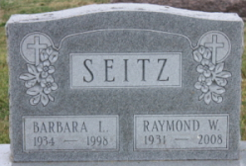
Photo by James Sheets

Barbara Lou Marbaugh
in the U.S., Social Security Applications and Claims Index, 1936-2007
Name Barbara Lou Marbaugh
[Barbara Lou Seitz]
[Barbara Seitz]
Gender Female
Race White
Birth Date 19 Jul 1934
Birth Place Mercer Count, Ohio
Death Date 16 Oct 1998
Father Wilbur Marbaugh
Mother Wanda Brough
SSN xxx
Notes Jun 1951: Name listed as BARBARA LOU MARBAUGH; : Name listed as BARBARA LOU SEITZ; 10 Nov 1998: Name listed as BARBARA L SEITZ

