Russell Ferdenard Seither
January 31, 1907 – September 29, 1977

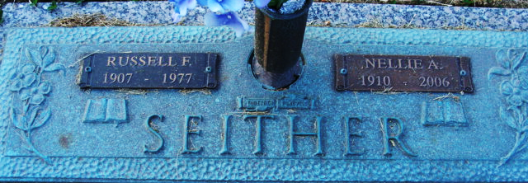
Photo by Alicia Kneuss

Russell Frederand Seither
in the Pennsylvania and New Jersey, U.S., Church and Town Records, 1669-2013
Name Russell Frederand Seither
Baptism Age 0
Event Type Baptism
Birth Date 31 Jan 1907
Baptism Date 5 May 1907
Baptism Place Philadelphia, Philadelphia, Pennsylvania, USA
Denomination Methodist
Organization Name Kensington Methodist Episcopal Church
Father Ferdenard Seither
Mother Elizabeth Seither
**
U.S., Newspapers.com™ Obituary Index, 1800s-current
Name Russell F. Seither
Gender Male
Death Age 71
Birth Date abt 1906
Residence Place Lancaster, Pennsylvania, USA
Death Date 29 Sep 1977
Death Place Idaho Falls, Bonneville, Idaho, USA
Burial Place Lancaster, Pennsylvania, USA
Obituary Date 2 Oct 1977
Obituary Place Lancaster, Pennsylvania, USA
Newspaper Title Sunday News
Spouse Nellie Meilott Seither

