Nellie A. (Mellott) Seither
May 23, 1910 – April 9, 2006

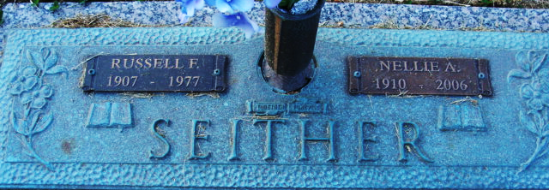
Photo by Alicia Kneuss

Nellie A. Seither, 95, Decatur, mother-in-law of a former Jay County resident, died Sunday at Swiss Village in Berne. Born in Pennsylvania on May 23, 1910, to Ira D. and Sarah A. (Bennett) Mellott, she married Russell F. Seither on Nov. 9, 1935. He died on Sept. 29, 1977.
Survivors include a daughter; son-in-law, L. Dale Gagle, Decatur, a former Jay County resident; four grandchildren; six great-grandchildren and three great-greatgrandchildren.
Services are on Saturday at 10 a.m. at Haggard and Sefton Funeral Home in Decatur. Burial will be in the Decatur Cemetery. Visitation is Friday from 2 to 8 p.m. at the funeral home.
Memorials may be sent to St. Mark's United Methodist Church or the Arthritis Foundation.

Commercial Review, Jay County, Indiana
Wednesday, April 12, 2006

**
Indiana, U.S., Death Certificates, 1899-2017
Name Nellie A Seither
[Nellie A Mollett]
Gender Female
Race White
Age 95
Marital Status Widowed
Birth Date 23 May 1910
Birth Place Bedford County, Pennsylvania
Death Date 9 Apr 2006
Death Place Berne, Adams, Indiana, USA
Death Registration Date 2006
Father Ira D Mollett
Mother Sarah A Bennett
Informant Janet Gagle; daughter; Decatur, Indiana
Burial April 15, 2006; Decatur Cemetery; Decatur, Indiana

