Elmer William Seip
March 16, 1927 – March 2, 2002

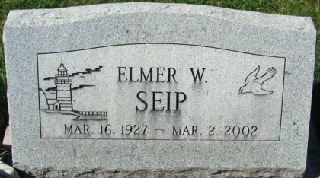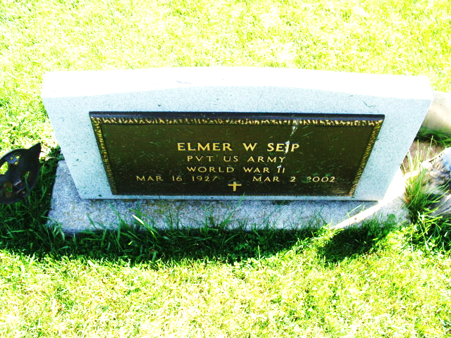
Photo by Alicia Kneuss

Elmer William Seip
in the U.S., Social Security Applications and Claims Index, 1936-2007
Name Elmer William Seip
[Elmer W Seip]
Gender Male
Race White
Birth Date 16 Mar 1926 (sic)
Birth Place Philadelphia, Pennsylvania
Death Date 2 Mar 2002
Father Edwin U Seip
Mother Emma Wissman
SSN xxx
Notes Oct 1942: Name listed as ELMER WILLIAM SEIP; 07 Mar 2002: Name listed as ELMER W SEIP
**
Rev. Elmer William Seip in Seip/Steele Family Tree
Spouse Jessie Leona Shiver
Father Edwin Ulmer Seip
Mother Emma Florence Wissman
Children Andrew Edwin
Birth 16 Mar 1926 Philadelphia, Philadelphia, Pennsylvania, USA
Death 2 Mar 2002 Live Oak, Washington, Florida, USA
Residence Abt 1978 Clearwater, Pinellas, Florida, USA

